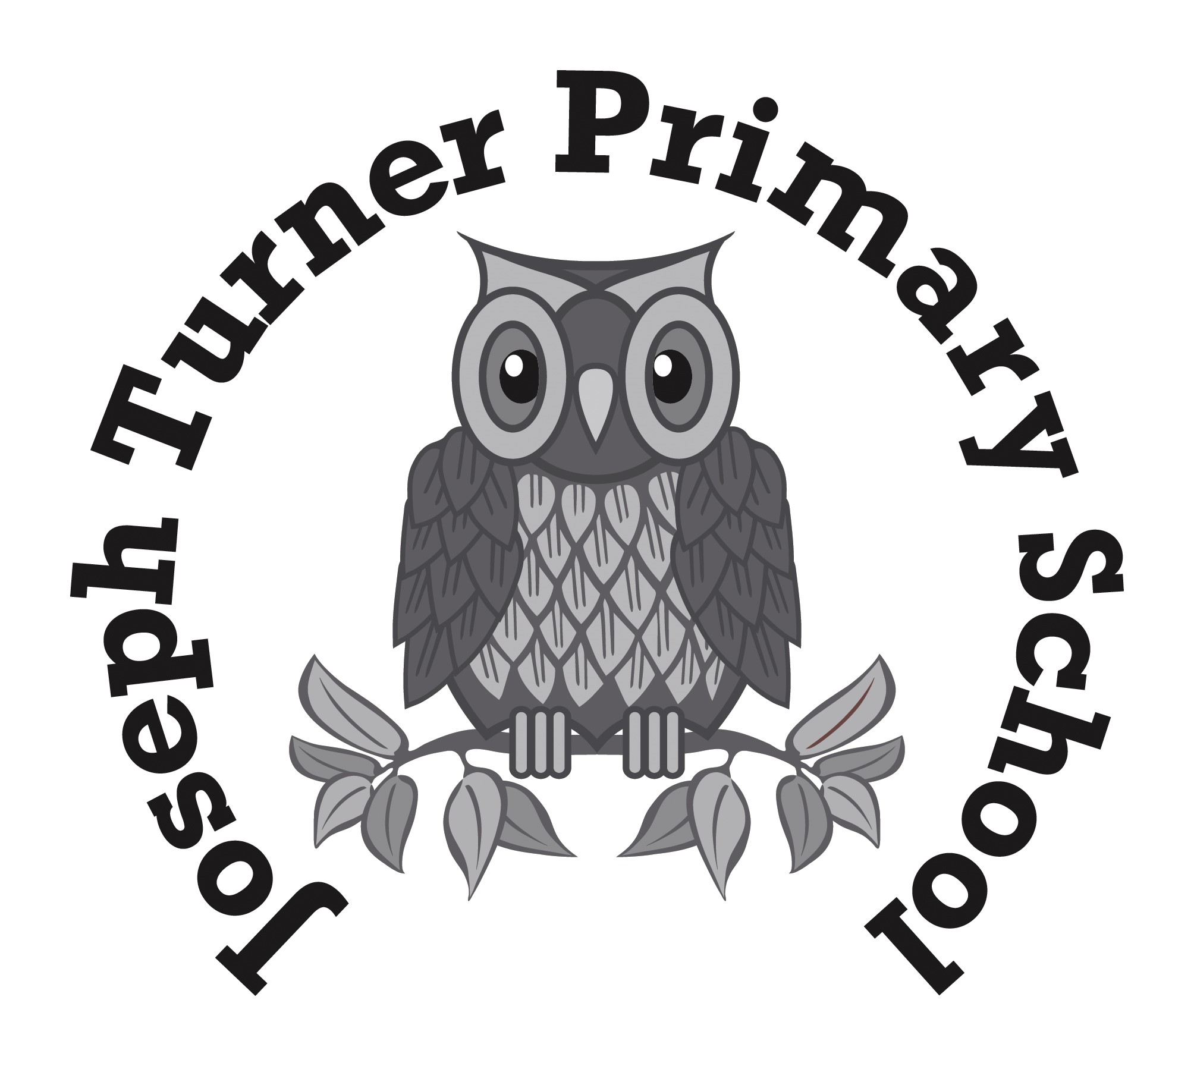Headteacher: Mrs L. Collins | Powis Avenue  Tipton  West Midlands  DY4 0RN  Tel: 0121-557-8733  Fax: 0121-557-6774

Dear Parent/Guardian, 9th January 2025

Year 5 day trip to West Midland Safari Park
Tuesday 25th February 2025

We have organised a trip for Year 5 pupils to visit West Midland Safari Park on Tuesday 25th February.

We will leave school at 9:00 am and travel by coach to the venue. We will return to school by 3:30pm.

The cost per child is £24.00. The cost includes coach travel, activities and insurance. Please do not send your child with any spending money.

Dolce, our catering provider can provide a packed lunch for your child at a cost of a normal school meal £2.75.
The cost will be added to your child’s SchoolGrid account, and paid in the same way you pay for a school meal.
If your child receives a Free School Meal because of the benefits you receive, a packed lunch will be provided free of charge. All packed lunches (paid or free) need to be ordered on the order form (please see link below, which can also be found in the email).

If you choose to send in your own packed lunch, please ensure it is in a labelled carrier bag which can be thrown away afterwards (therefore pupils do not have to carry boxes, bags or flasks for the duration of the day). Drinks should be in disposable cartons or plastic bottles (no cans or glass bottles please) and we would ask you not to send chocolate or fizzy drinks.

Please note children will need to wear their school uniform and appropriate footwear.

In line with Health and Safety legislation, our staff will spend a considerable amount of time completing the relevant paperwork to ensure all children are safe and all medical conditions are managed appropriately. The signed one-off consent form for off-site and out of hours activities will be used for this trip.

Please ensure you have provided all medical information concerning your child, and up to date emergency
contact numbers.

Payment is to be made online via the ‘SchoolMoney’ Account (www.eduspot.co.uk) or using the SchoolMoney
App. If using the website, click on the sign in button in the top right hand corner. In the drop down select School
Money parent login option.

Deadline for payment and packed lunch order is Friday 7th February 2025.
Link to Lunch Order Form (https://forms.office.com/e/tezjACSLr2)

Yours faithfully

Mrs L. Collins
Head Teacher

