



A step by step guide for parents

Step by step guide

In addition to the instructions below, there is also a video that goes through and explains how to use SeeSaw https://www.youtube.com/watch?v=g5jG9VoROFs

Step 1: On your smart device (phone, tablet, ipad etc.) download the SeeSaw app. Or visit the SeeSaw website if using a laptop or PC.
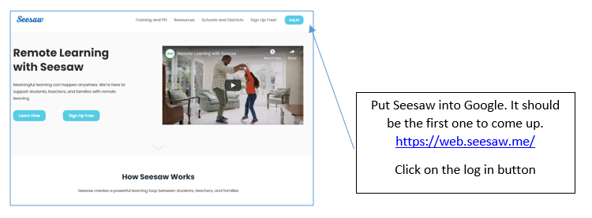

Step 2: Open the app. You will see a screen with two buttons: ‘I'm a Teacher’, ‘I'm a Student’. Click the 'I'm a Student' button.
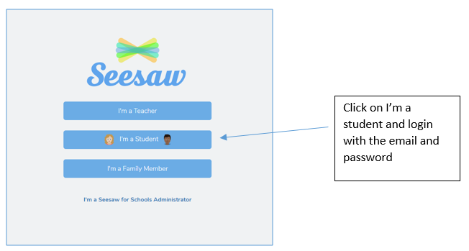

Step 3: A smaller box should pop up. Input your child’s SeeSaw code into the text code box.
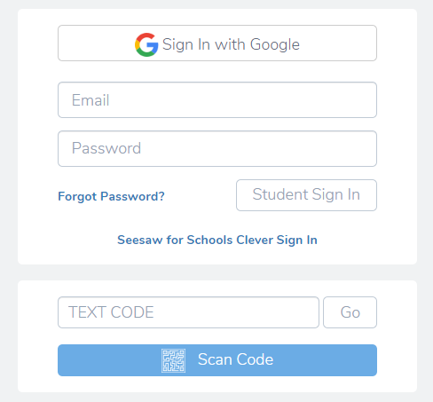
Log in with the 12 letter code and click go.

Step 4: Once logged on, you will be on the home screen for your child’s class. You will see 3 buttons on the right hand side of the screen: ‘Journal’, ‘Activities’, ‘Inbox’. All new home learning activities will be posted into the ‘Activities’ section so click on the ‘Activities’ button (the one with the lightbulb).
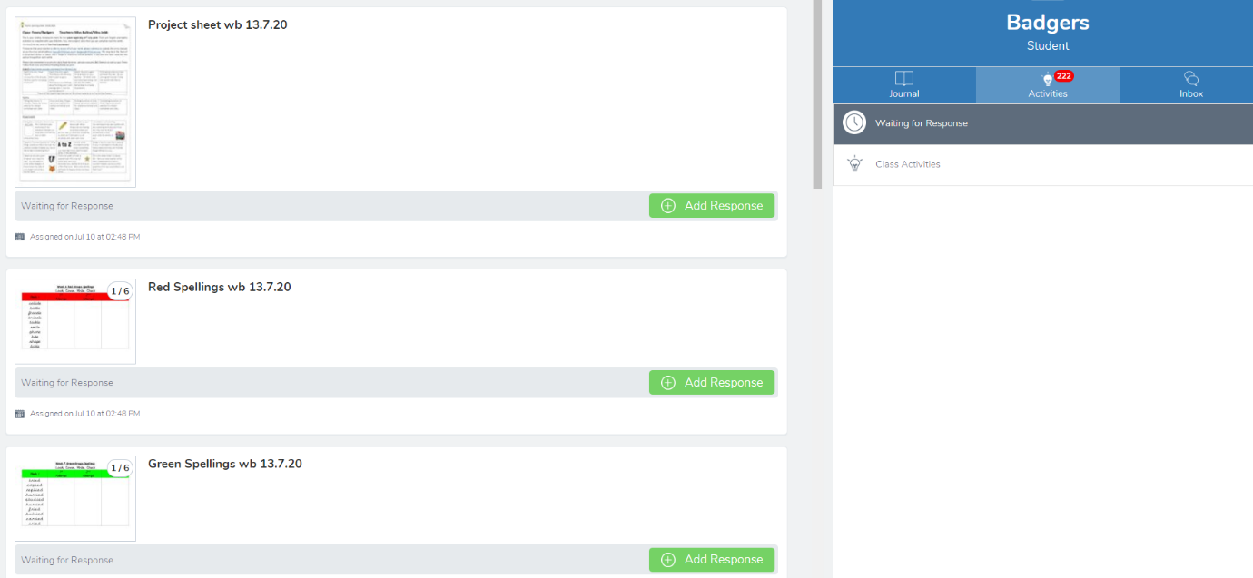

Step 5: The tasks for that day will be present in the ‘Activities’ section. Choose the task you'd like your child to do and click on it for more details (there will be a text explanation and sometimes there may even be a video to accompany the task). Once you have clicked on the add response button, the next screen will appear for you to edit the item.
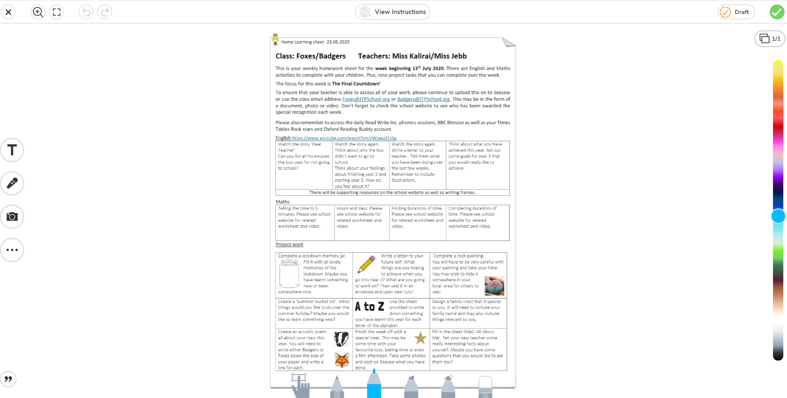
Draw a text box
Record a voice message
Take a photo
This will change the colour of the pens
Here you can choose a range of pens, pencils and highlighters

Step 6: Some tasks will have specified if you are to take a picture or a video to share your child’s work. You can also edit the document that has been posted as shown above,
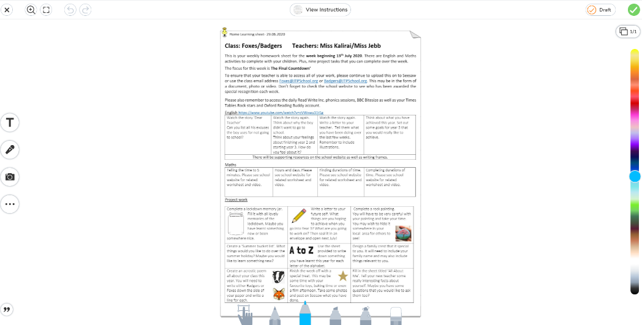
Once you have finished, click on the green tick and this will save everything and post to back to the class teacher.

