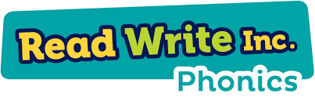

Here is a copy of the sound mats we use in school. These show you the order in which Set 1, Set 2 and Set 3 sounds are taught.


