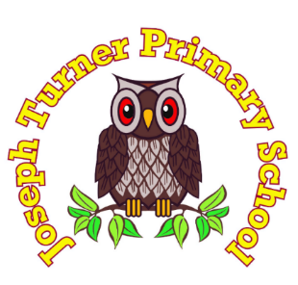

Reception Graduation
Children in Reception will soon be finishing their EYFS education and moving up into Key Stage One.

To celebrate, we will be holding a Graduation ceremony in the hall on:

Wednesday 15th July
At 9:10-10:10am
Parents and carers are invited to join us for our Graduation ceremony.
This will be a celebration of their time in Reception, and chance for us to share some of the things we have learnt this year.
Please make your way to the main entrance and a member of staff will sign you in.

Thank you for your continued support.
We look forward to seeing you there!

