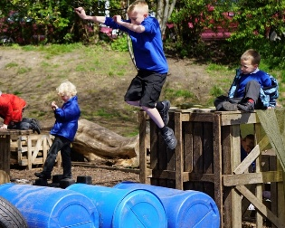

Risky Play

Pupils will…
Challenge and try new things.
- Think before we act and make sensible choices.
- Look after ourselves and others when playing.
- Use equipment and resources for their intended purpose.
- Recognise and respect our own limits and the limits of others.
- Listen to adults and Play Team members when they give safety instructions.
- Stop and ask for help if something does not feel safe.
- Take responsibility for our actions and the choices we make.
- Follow agreed boundaries, rules or instructions.
We Will Not:
- Deliberately put ourselves or others in danger.
- Force anyone to take part in activities they do not feel comfortable doing.
- Use equipment in a way that could cause harm to people or property.

Why we expect to see this behaviour…

- To ensure lunch times are safe, successful and enjoyable.
- To develop communication and social skills
- To be ready, respectful and safe.
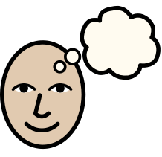

School adults will…
- Encourage children to challenge themselves safely.
- Promote inclusion and ensure everyone feels welcome.
- Help children assess risks rather than remove all risks.
- Follow and promote the OPAL Play Charter and school values.
- Report unsafe equipment, damaged resources or concerns to an adult.
- Help maintain tidy and organised play areas at the end of playtime.
- Support children to solve problems and find solutions independently where possible.
- Communicate using walkie talkies and implement the behaviour policy
- Respect children's play and allow them to take appropriate risks.

Sanctions/consequences for not following expectations

- Moved to a different area
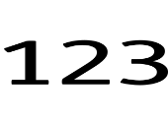

- Spending period of time in behaviour recovery
- Informing parents.
- Apply behaviour policy. (using staged approach)

